|  |  |
| --- | --- |
| Unipress weld failure investigation  Part 75112/6CA0A/JA000 | REPORT  The following document will discuss observations made of both formed and unformed parts on and near the laser welds which joined two metal blanks into one continuous part prior to forming in a five process press.  Shane M Palmquist, PDH,PE  Associate Professor & director EMCC.  Martin Cohron , Research support Coordinator / Nova Center |

During polishing and etching process of the blanks (unformed part in the flat state), a pushing or pulling of the molten puddle of the laser weld was observed. The following two photos (figures 1 and 2) and many of the SEM images (first 6 SEM images) clearly show this observation. This was communicated to Mr. Thomas Moss of Unipres during a visit to WKU while delivering more parts. Without additional knowledge of the welding process, it is not possible to determine if the weld puddle is being pulled or pushed. There appears to be as much metal absent from the weld line opposite the end which seems to be raised from the weld puddle push or pull.

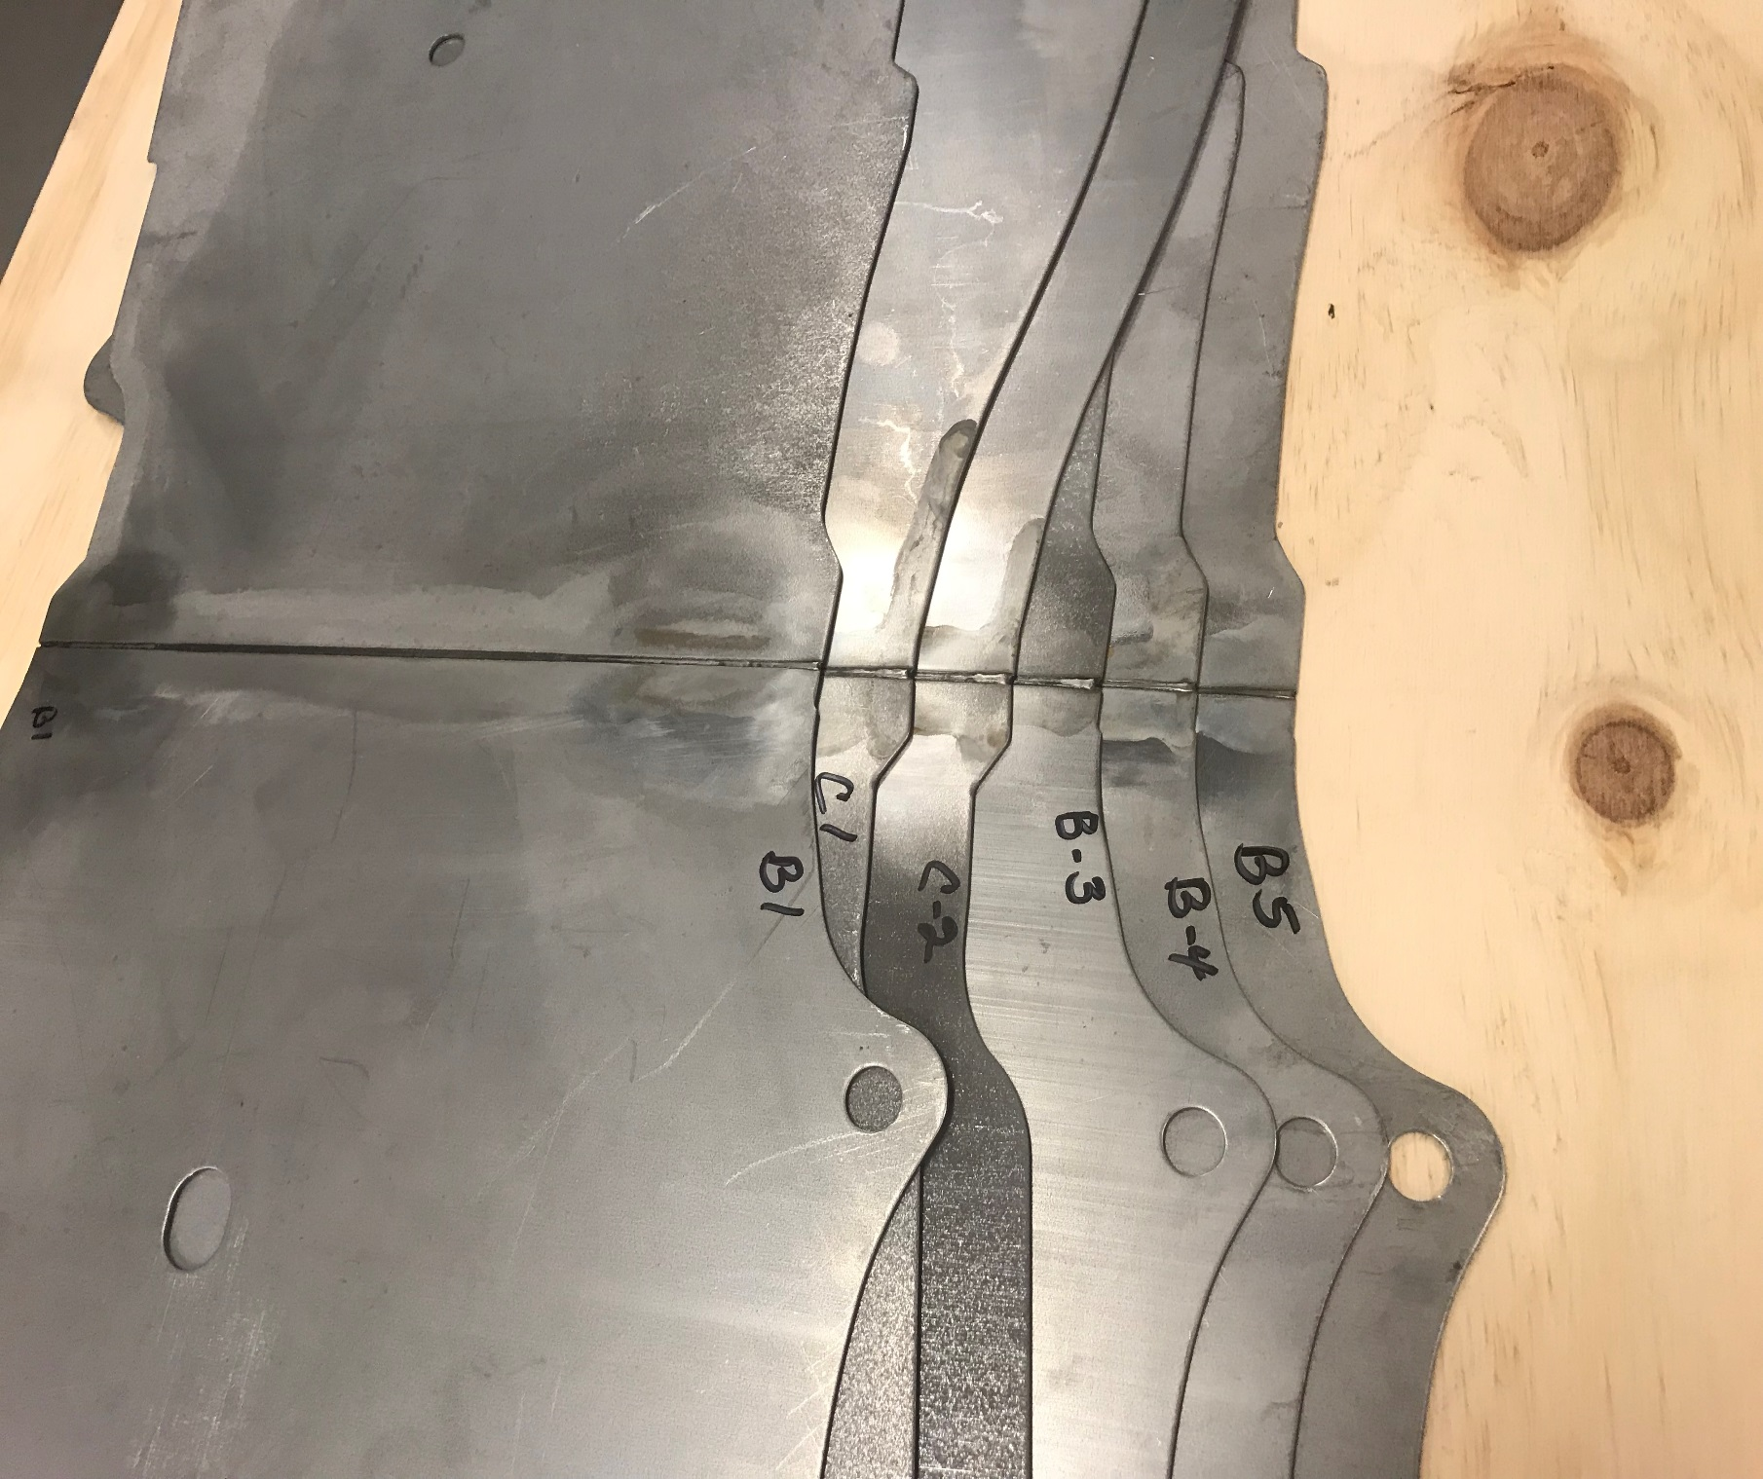

Figure 1. Unformed blank parts

From Figure 1, the orientation of the part to the weld appears to be reversed on parts C1 and C2 as compared to parts B1 thru B5. While the orientation is different, the weld direction is common with the B series parts. Therefore, microstructural images based on the same orientation with regard to the weld direction were made using the large chamber scanning electron microscopic at the NOVA Center at Western Kentucky University.

The LC-SEM is a large chamber scanning electron microscope used for high resolution imaging. This unique, highly specialized instrument accommodates full-size, large objects up to 3’-0” by 3’-0” by 3’-0” in size, eliminating the need of cutting large objects into smaller quarter sized specimens that are easily damaged during the cutting process. This world-class instrument has a magnification power of up to 300,000x. The images generated by the instrument have a resolution greater than 10 nm. For more information about LC-SEM, see last page of this report.

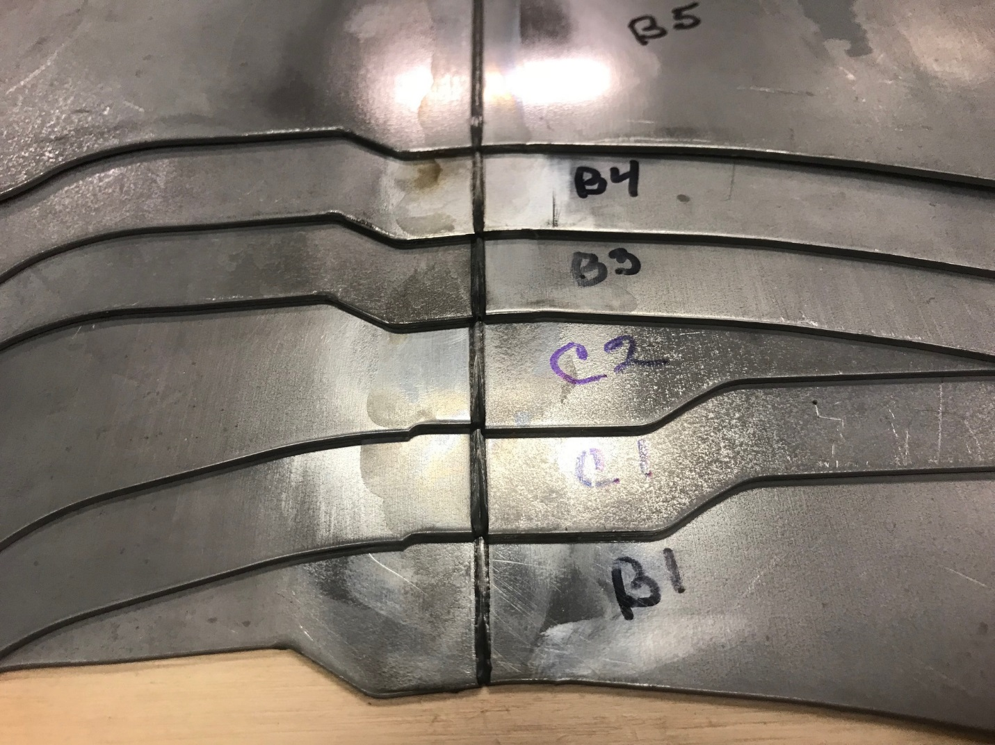

Figure 2. Weld start ends of blank parts

All of the excess metal on the weld bead is on the same end of the blanks as shown in Figure 1. Figure 2 shows what appears to be the starting of the weld on six (6) different pieces moving upward in the photo. The end of each weld of every blank part was first examined at low magnification. Similarities of the weld end were observed in each blank part. All of the parts appeared to have gaps in the weld which seem to be the starting point of the tearing as observed in the formed parts. Some of the blank parts show the beginning of splits before forming was attempted.



LC-SEM image, part B5



LC-SEM image, part B4



LC-SEM image, part B3

B3



LC-SEM image, part C2

C2



LC-SEM image, part C1

C1



Interior

Weld Separation

LC-SEM image, part B1

B1

Examining the interior separation of blank part B1, interior cracking was observed as shown in LC-SEM images B1-1 and B1-2.



500x

LC-SEM image B1-1

B1



2000x

LC-SEM image B1-2

B1

This type of cracking was typical of the “rough” weld starts, and this is a contributing factor in weakening of the weld end prior to the forming processes.

The next part of this study examined grain structure of the material. Polishing and etching of the part surfaces at and near the weld ends did reveal structure grains @ 3000x.



Center of LC-SEM image is 0.5 mm from weld edge. Red line with arrow indicates direction to the weld, part B1.

Blue line appears to be change in structures beginning point.

Part B1 was examined at 0.5 mm moving to the right of the weld as shown in the LC-SEM image above. The fracturing in the formed pieces has been consistently on the right side of the blank part with the same orientation of blank parts B5, B4, B3 and B1.



LC-SEM image to the left is at 1 mm right of the weld, part B1.

Notice the fragmented grains to a more common structure.



2 mm right of weld, part B1.



4 mm right of weld, part B1.



0.2 mm from weld moving left



1 mm from weld moving left



2 mm from weld moving left.

The above three (3) LC-SEM images are moving left of the weld, same orientation as pages 7 and 8.



0.2 mm



0.5 mm

The next four (4) LC-SEM images are of formed piece #3 process 1. The blue line indicates the parallel to weld orientation. LC-SEM images will be moving to the right of the weld.



1 mm



2 mm right of weld #3 process 1



4 mm right of weld formed 3 process 1

On page 12, there are three (3) LC-SEM images showing the transitional area at 0.2 mm and moving left of the weld. The surface of the weld appears to recover to full integrity at 1 mm away.



0.5 mm

0.2 mm

1 mm

Request were made by **Unipres** to look at the separation or tears back to back with the edges facing the microscope view. The metal appears to have thinned significantly before the actual failure.



BTB B3 150x



Total and actual failed area are shown above. 3 sections were

**WKU ReceiveS $2.7 Million large chamber Scanning Electron Microscope**

*Bowling Green, Ky.* - Western Kentucky University received a $2.7 million gift from the U.S. Department of Energy – one of the world’s largest scanning electron microscopes.

<http://alumni.wku.edu/s/808/index.aspx?sid=808&gid=1&pgid=252&cid=2206&ecid=2206&ciid=4475&crid=0>

